**Experiment 1**

**Title:** Explore Linux commands

Explore the usage of basic Linux Commands and system calls for file, directory and process management.

For eg: (mkdir, chdir, cat, ls, chown, chmod, chgrp, ps etc.

system calls: open, read, write, close, getpid, setpid, getuid, getgid, getegid, geteuid. sort, grep, awk, etc.).

**Estimated time to complete this experiment:** 2 hours

**Objective:** To understand the Linux commands & System calls

**Expected Outcome of Experiment:** Understanding the usage of Linux commands and System calls.

**Books/ Journals/ Websites referred:**

1. William Stallings, Operating System: Internals and Design Principles, Prentice Hall, 8thEdition, 2014, ISBN-10: 0133805913 • ISBN-13: 9780133805918.
2. Abraham Silberschatz, Peter Baer Galvin and Greg Gagne, Operating System Concepts, John Wiley &Sons, Inc., 9thEdition, 2016, ISBN 978-81-265-5427-0
3. Maurice J. Bach, “Design of UNIX Operating System”, PHI
4. Sumitabha Das, “UNIX: Concepts and Applications”, McGraw Hill, 4thEdition

**Pre Lab/ Prior Concepts:** Linux OS

**Historical Profile:** Linux began in 1991 as a personal project by Finnish student Linus Torvalds: to create a new free operating system kernel. The resulting Linux kernel has been marked by constant growth throughout its history. Since the initial release of its source code in 1991, it has grown from a small number of C files under a license prohibiting commercial distribution to the 4.15 version in 2018 with more than 23.3 million lines of source code, not counting comments, under the GNU General Public License v2.

**New Concepts to be learned:**  Linux Commands and System calls.

**Requirements:** PC with Linux OS.

**Flow Chart: -**

**Theory:**

**Linux Commands**

1. ls : Listing File and Directories Command

$ ls [ﬁles-or-directories]

- List ﬁles and/or directories. If no argument is given, the contents of current directory are shown.

example ﬁle1.txt ﬁle2.txt ﬁle3.txt

-If a directory is given as an argument, ﬁles and directories in that directory are shown.

1. mkdir command : To create a directory, the ‘mkdir’ command is used.

$ mkdir example

$ ls -l

1. cd.. command :

On Unix-like operating systems the current directory is represented by a single dot and its parent directory (i.e., the directory that contains it) is represented by two consecutive dots. Thus, it is possible (and often convenient) to change to the parent of the current directory by using the following:

cd ..

1. pwd command : ‘pwd’ command prints the absolute path to current working directory.

$ pwd

/home/raghu

1. echo command :

The ‘echo’ command is used to display the values of a variable. One such variable is ‘HOME’. To check the value of a variable precede the variable with a $ sign.

$ echo $HOME

/home/raghu

1. ps command :

A process, also referred to as a task, is an executing (i.e., running) instance of a program. Every process is assigned a unique PID by the system.

The basic syntax of ps is ps [options]

1. cp command :

If a directory is to be copied, then it must be copied recursively with the ﬁles contained in it. To copy a directory recursively, use -r option with ‘cp’ command:

$ cp ﬁle1 ﬁle2 example/

$ ls -l example/ total 4

1. move command :

$ mv source destination

Move ﬁles or directories. The 'mv' command works like 'cp' command, except that the original ﬁle is removed. But, the mv command can be used to rename the ﬁles (or directories).

$ mv listing_copy.txt usrcopy

$ ls -l total 12

1. rmdir command : To remove ﬁles and directories To remove or Delete.

'rmdir' command removes any empty directories, but cannot delete a directory if a ﬁle is present in it.

$ rm ﬁles|directories

A directory must be removed recursively with -r option.

$ rm ﬁle2

$ rm -r example/

$ ls -l total 8

1. cat command :

is used to view contents of a ﬁle or concatenate ﬁles, or data provided on standard input, and display it on the standard output.

$ cat ﬁle.txt

1. chgrp Command :

chgrp command is used to change the group ownership of a ﬁle. Provide the new group name as its ﬁrst argument and the name of ﬁle as the second argument like this:

$ chgrp tecmint users.txt

1. ls -l

The simple **command** of **ls** -**l** means, to list files and directories.

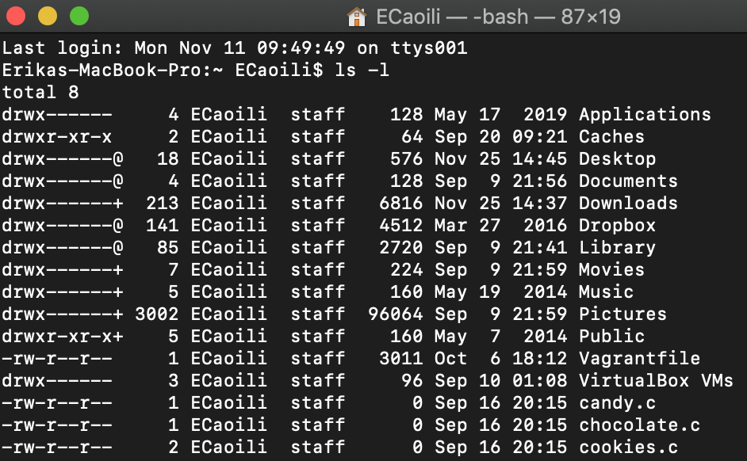

1. chmod Command

chmod command is used to change/update ﬁle access permissions like this.

$ chmod +x sysinfo.sh

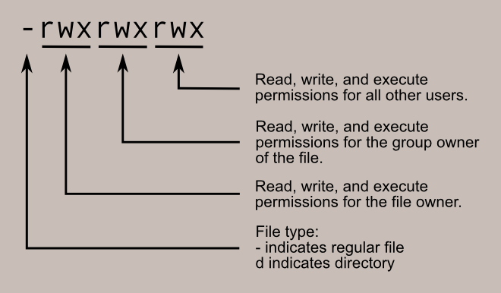

13. chown Command

chown command changes/updates the user and group ownership of a ﬁle/directory like this.

$ chmod -R www-data:www-data /var/www/

1. cd

The cd command is used to change the current directory (i.e., the directory in which the user is currently working) in Linux and other Unix-like operating systems. It is similar to the CD and CHDIR commands in MS-DOS.

cd's syntax is

cd [option] [directory]

1. ls-R :

The -R (uppercase R) option lists all subdirectories, recursively. That shows you the whole directory tree starting at the current directory.

1. rm command :

rm stands for ‘remove‘ as the name suggests rm command is used to delete or remove ﬁles and directory in UNIX like operating system.

# rm <options> {ﬁles}

1. chdir command :

chdir changes the current working directory of the calling process to the directory speciﬁed in path.

Syntax:

int chdir(const char *path);

1. sort command

The sort command is used to sort a file, arranging the records in a particular order. By default, the sort command sorts file assuming the contents are ASCII. Using options in sort command, it can also be used to sort numerically.

1. grep command

The grep command which stands for “global regular expression print,” processes text

line by line and prints any lines which match a specified pattern.

Use command: cat filename | grep pattern

1. awk commnd

 By default Awk prints every line of data from the specified file.

Syntax : awk options &#39;selection _criteria {action }&#39; input-file &gt; output-file

**Implementation**

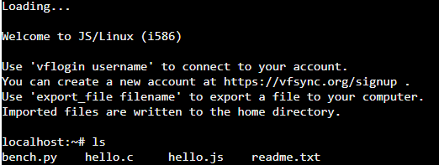

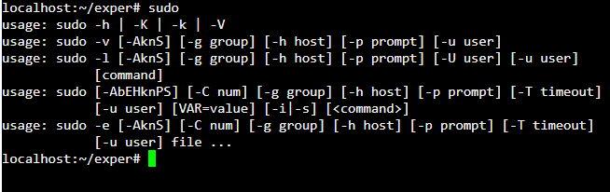

**Conclusion** Hence we have understood and used the various Linux Commands and System calls.

**Real-Life Application:**

1. Writing shell scripts